## Adjust Anchor Guy Feature for FAI

1. Open ArcCatalog and connect to **sde@eder.**
2. Copy the XML folder kept at below path and save it to your local space.

\\ffshare01-nas\etgisshare\Applications\Temp\ManagedService_Developement\Electric\ED\Deliverables_Q3_(Jul-Sep)_2017\To_Onsite\ED\EDER\Anchor

1. Follow the below mentioned steps to import the excel into EDER:-
2. Right click on EDER, go to Import and click on XML Workspace Document.

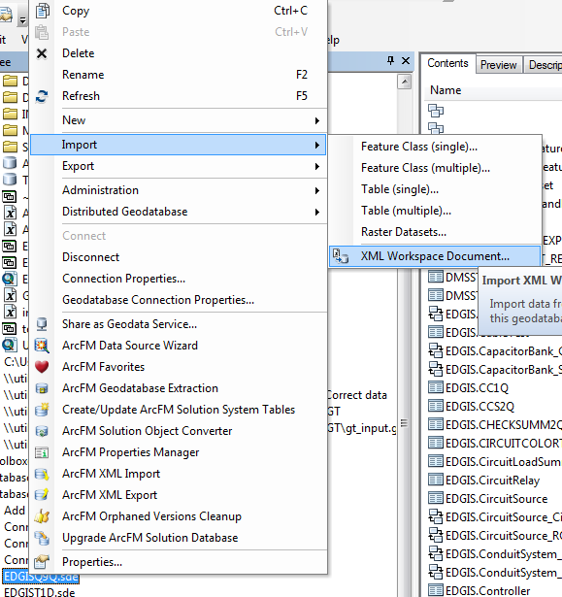

1. Choose **Schema Only** and browse the “**ANCHORGUYXMLEXPORT.XML** ”file and provide the path.

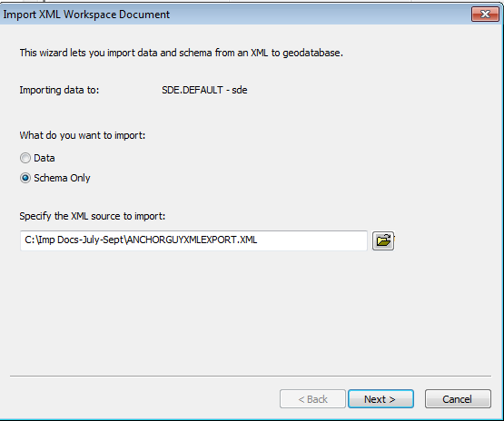

1. Click Next and then Finish.
2. Now drag and drop **EDGIS.Anchor** from EDGIS.ElectricDataset_1 to EDGIS.ElectricDataset.

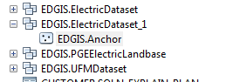

1. After the drop, delete EDGIS.ElectricDataset_1.
2. Now, right click on dataset”EDGIS.ElectricDataset”🡪Manage 🡪Register as Versioned.

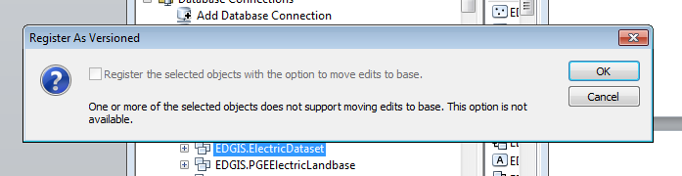

1. Right Click “EDGIS.Anchor” and navigate and click on “ArcFM Solution Object Converter”, It will open following window, Click “Ok” to proceed.

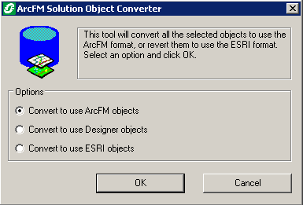

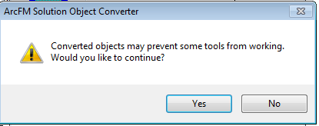

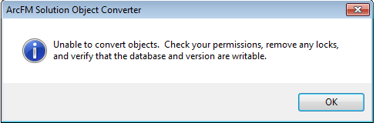

1. Right Click “EDGIS.Guy” and navigate and click on “ArcFM Solution Object Converter”, It will open following window, Click “Ok” to proceed.







1. Similarly Right Click “EDGIS.Guy” and Navigate “Manage>>Privileges” and set as below:

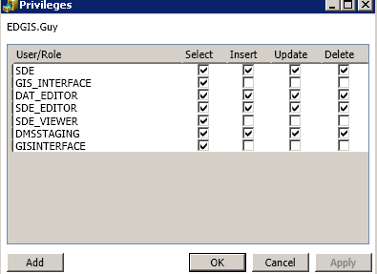

1. Now again right click on EDER and select ArcFM XML Import.

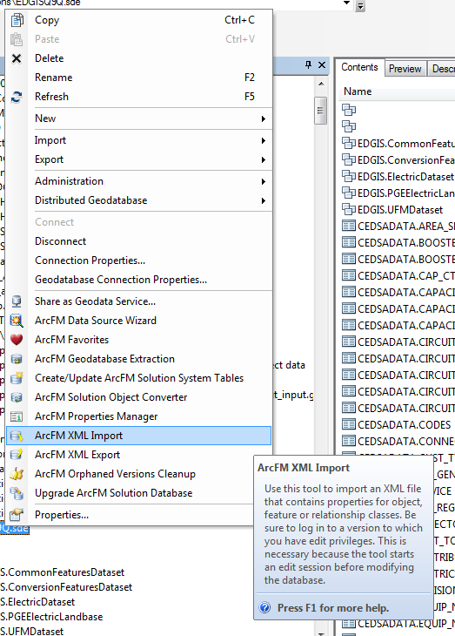

1. After this choose Overwrite and browse the “**ANCHOR_ARCFMEXPORT.xml**” file from the XML folder saved at local space.

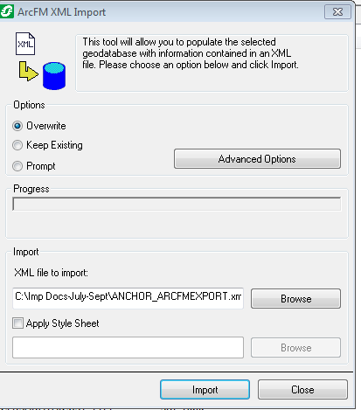

1. Click Import. After this click No.

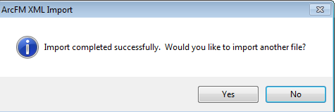

1. Now again right click on EDER and select ArcFM XML Import.



1. After this choose Overwrite and browse the “**GUY_ARCFMEXPORT.xml** ” file from the XML folder saved at local space.

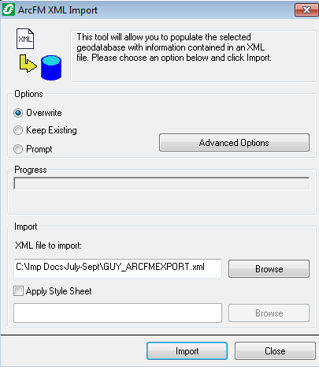

1. Click Import. After this click No.



1. Now right click on ‘EDGIS.Anchor’. Go to Properties and Feature Extent tab. Fill the values as shown in image. Click OK.

## 

## Creating Relationships

**1**) A relationship should be created from “**EDGIS.JointOwne**r” infotable to the “**EDGIS.Anchor**” feature class.

1. To create a relationship, right click on the database. Go to New and then Choose Relationship Class as shown in the below image.

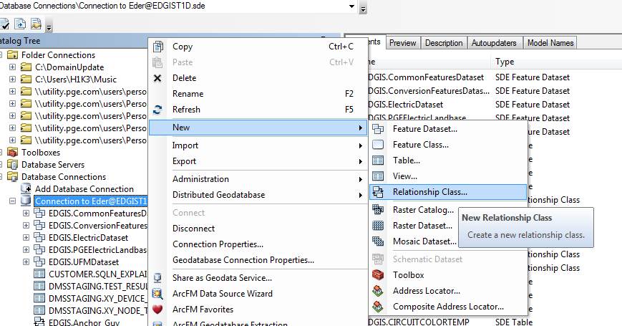

1. Write name of the relationship class as “Anchor_JointOwner”.
2. Origin table - ‘EDGIS.Anchor’
3. Destination table - ‘EDGIS.JointOwner’
4. Refer to the below image and click Next.

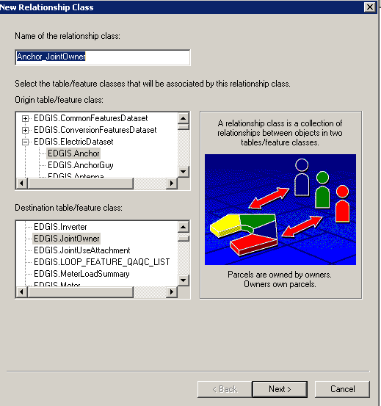

1. Choose simple (peer to peer) relationship.

## 

1. Check the following image, click on forward and procced.

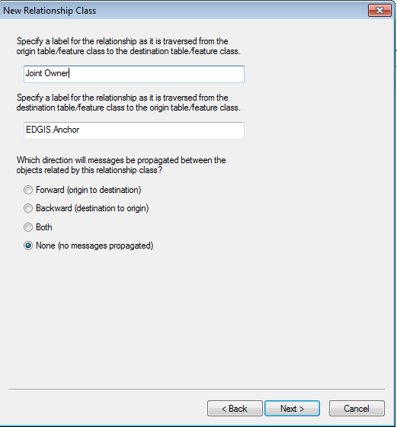

1. Click on 1-M and Next.

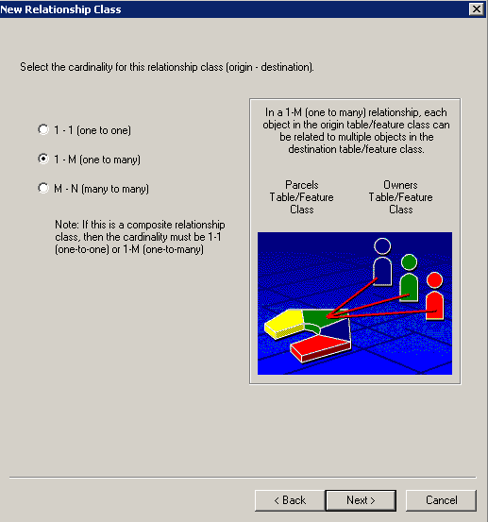

1. Do as shown in following image and click Next.

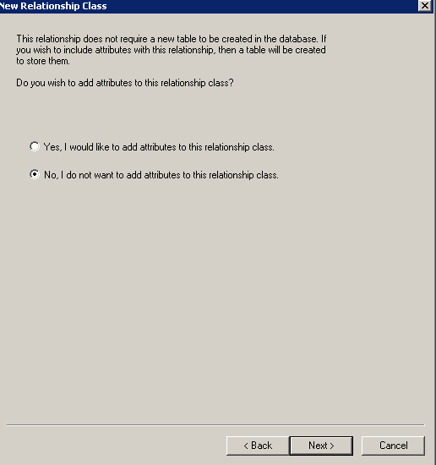

1. Choose the primary key and foreign key.

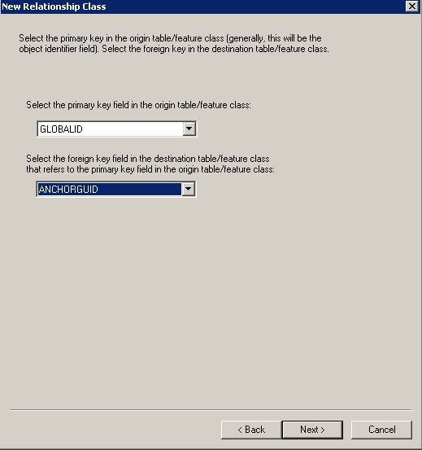

## 

1. Click Finish.

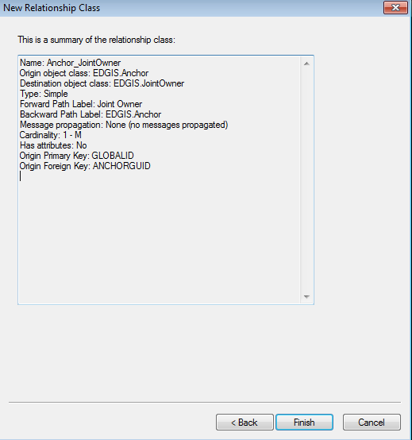

**2**) Create a new relationship from “**EDGIS.Anchor**” feature class to “**EDGIS.SupportStructure**” feature class.

1. Write name of the relationship class as “**SupportStruct_Anchor**”.
2. Origin table - ‘EDGIS.SupportStructure’
3. Destination table - ‘EDGIS.Anchor’
4. Refer to the below image and click Next.

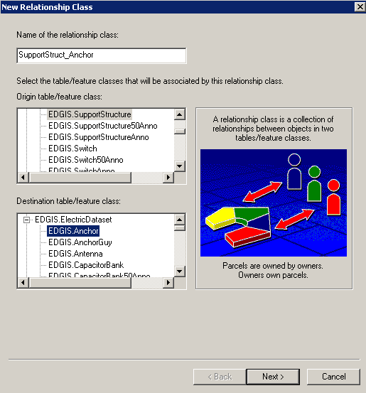

1. Perform the following steps by taking reference from images. Click Next.

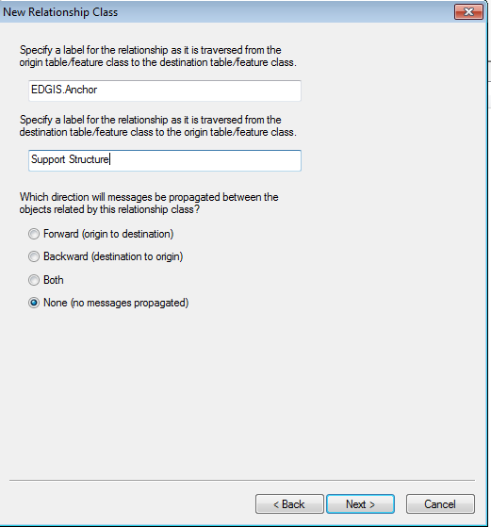

1. Click on **1-M** and Next. Click Next and then again Next.

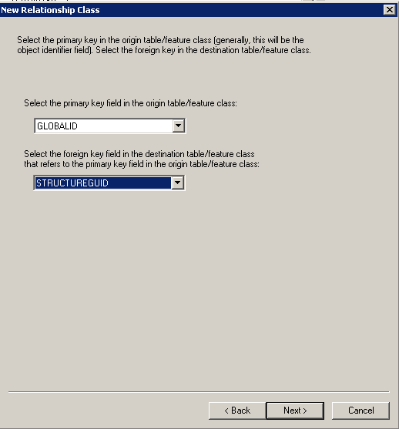

1. Click Finish.

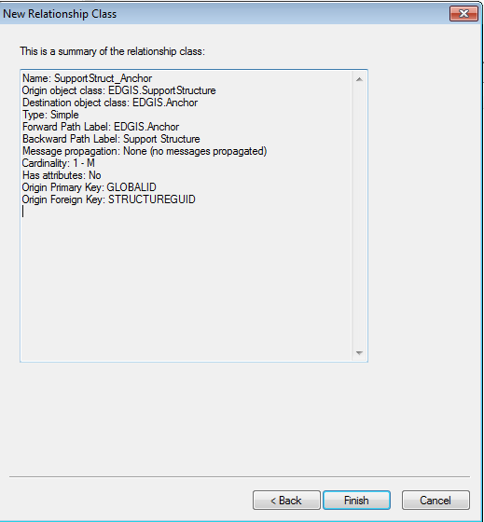

**Steps for One Time Migration Activity from EDGIS.AnchorGuy Feature Class to EDGIS.Anchor and EDGIS.Guy**

1) Make sure below three files are in same folder.

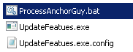

2) Update following tag in *UpdateFeatues.exe.config* as per environment

<add key="CONN_EDGIS_FILE" value="C:\Users\v1si\AppData\Roaming\ESRI\Desktop10.2\ArcCatalog\EDGIST1D@RELEDITOR.sde" />

3) Open Command Prompt and set the path to the location where above three file exists

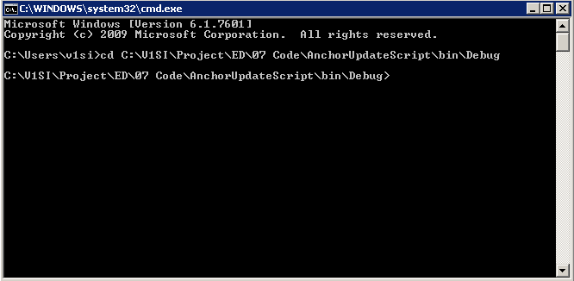

4) Type “**ProcessAnchorGuy.bat”** and Hit “Enter” as below to run the program, After Hit it will create 10 more command window where the processing will start. (Approximately it will take 4-5 hours to complete all the process)

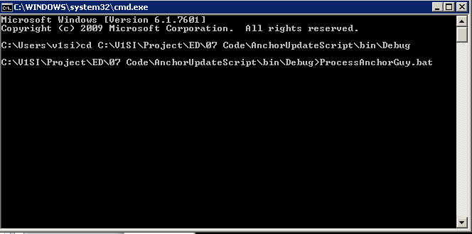

**Steps for Map Production-1 Configuration Changes:**

1) Following changes has been performed on “EDGISExtract.Config.xml” kept at for your reference

\\ffshare01-nas\etgisshare\Applications\Temp\ManagedService_Developement\Electric\ED\Deliverables_Q3_(Jul-Sep)_2017\To_Onsite\ED\EDER\Anchor\Map_Prod_1_Configuration

**Before:**

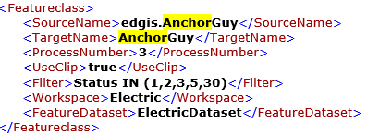

**After:**

<Featureclass>

<SourceName>edgis.Anchor</SourceName>

<TargetName>Anchor</TargetName>

<ProcessNumber>3</ProcessNumber>

<UseClip>true</UseClip>

<Filter>Status IN (5,30)</Filter>

<Workspace>Electric</Workspace>

<FeatureDataset>ElectricDataset</FeatureDataset>

</Featureclass>

**Before:**

<Featureclass>

<SourceName>lbgis.CorporateProperty</SourceName>

<TargetName>CorporateProperty</TargetName>

<ProcessNumber>5</ProcessNumber>

<UseClip>true</UseClip>

<Filter></Filter>

<Workspace>Landbase</Workspace>

<FeatureDataset>PGE_Common_Landbase</FeatureDataset>

</Featureclass>

**After:**

<Featureclass>

<SourceName>lbgis.PGE_PARCELS</SourceName>

<TargetName>PGE_PARCELS</TargetName>

<ProcessNumber>5</ProcessNumber>

<UseClip>true</UseClip>

<Filter></Filter>

<Workspace>Landbase</Workspace>

<FeatureDataset>PGE_Common_Landbase</FeatureDataset>

</Featureclass>

**Steps for DWG Changes to be published:**

1) Following FMW needs to be published from below path:

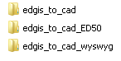

\\ffshare01-nas\etgisshare\Applications\Temp\ManagedService_Developement\Electric\ED\Deliverables_Q3_(Jul-Sep)_2017\To_Onsite\ED\EDER\Anchor\DWG_FME

Steps to be performed for publishing:

* Open “edgis_to_cad.fmw” in FME Work and publish it on FME server. Once the publication process has been done, we have updated service -http://<servername>/fmedatadownload/EDGIS_PREPD/edgis_to_cad.fmw
* Repeat above step for “edgis_to_cad_ED50.fmw” and “edgis_to_cad_wyswyg.fmw”